EXPERIMENT-6

DML COMMANDS (COLLEGE SCHEMA)

Aim:

* Insert 5 instances into the tables created in experiment 5.
* Display the tables.
* Add attribute course to student table then insert values.
* Use update to set course for students.
* Delete an attribute.

MySQL:

insert into faculty values(22, "Mrs.Sundari", "DBMS", 90);

insert into faculty values(24, "Mrs.Roja Rani", "BEFA", 95);

insert into faculty values(25, "Mr.Muralinath", "DM", 90);

insert into faculty values(26, "Mr.Rajesh", "JP", 90);

insert into faculty values(27, "Mrs.Swapna", "OS", 95);

SELECT \* FROM faculty;

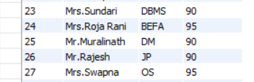

insert into student values(34, "M. Sashi", "Maths", 97, "A", "F");

insert into student values(35, "P. Raghu", "Maths", 91, "A", "M");

insert into student values(36, "K. Keerthi", "Maths", 68, "B", "F");

insert into student values(37, "M. Surya", "Maths", 42, "C", "M");

insert into student values(38, "T. Priya", "Maths", 53, "C", "F");

insert into student values(39, "R. Vishal", "Maths", 25, "E", "M");

select \* from student;

insert into department values (1, "CSE", 200, 75), (2, "ECE", 230, 75), (3, "EEE", 200, 75), (4, "IT", 150, 75);

insert into activity values(1001, "Group Discussion", 45, "Communication", "Ms. Rani") ;

insert into activity values(1002, "Dancing", 48, "Cultural", "Mr. Raju");

insert into activity values(1003, "Painting", 50, "Arts", "Ms. Padma");

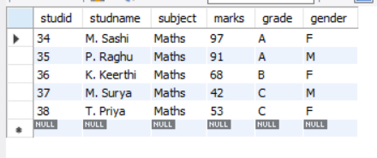

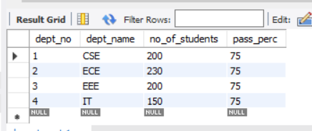

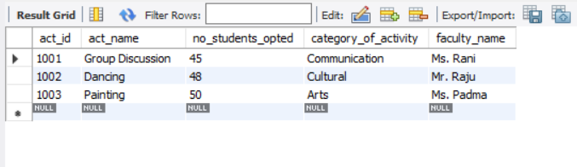

ALTER TABLE student ADD(course varchar(20));

UPDATE student SET course = "CSE" WHERE studid = 34;

UPDATE student SET course = "IT" WHERE studid = 35;

UPDATE student SET course = "IT" WHERE studid = 36;

UPDATE student SET course = "CSE" WHERE studid = 37;

UPDATE student SET course = "CSE" WHERE studid = 38;

ALTER table student drop gender;

